Introducing MovieMaker (a video capture and video editing program that comes with the Windows Operating System)
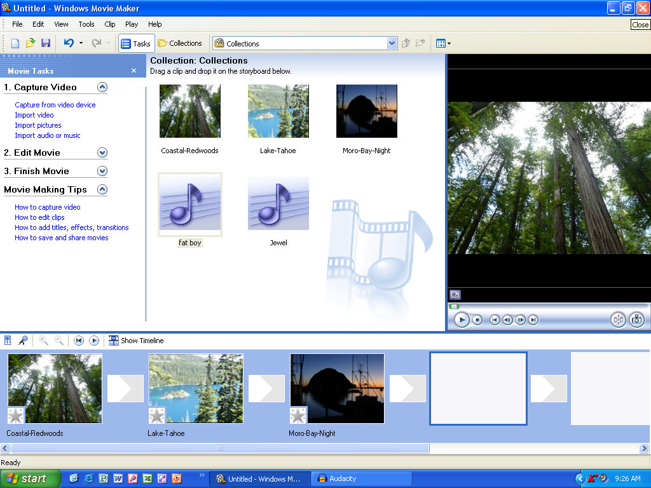

Question | Answers
What are the 3 main capabilities of MovieMasker? (See left column.)
What sort of media can MovieMaker capture?
What are the two “views” of Moviemaker?
Which view lets you add sound?
Write one way to add a video transition?

